 | Epsom & Ewell F.C.  10  v  Guildford City  Saturday, 2nd December 2017 – 3.00 p.m.
Good afternoon and welcome to High Road for our League match against Guildford City. We welcome their players, supporters and officials and wish them a safe journey home, as of course we do for our own regular faces.

We have already hosted our opponents twice this calendar year with two meetings here in consecutive weeks in January. Neither were particularly inspiring matches and each team won one of them by a goal to nil. Our win came in the league which enabled us to ultimately finish fourth, whilst Guildford defeated us in the Surrey Senior Cup, using that result to help them progress all the way to the Semi-Final.

Our last performance here came against Godalming Town who totally deserved their 3-0 win on the night. I had assumed at some point that they would use their Slough Town connections and bring in a few half decent player or two, but I certainly didn’t expect them to have a New Zealand Youth International who was playing for Slough’s first team just six weeks ago!

Following that match we visited Balham, where we were defeated 4-0. We trailed at the half to a thirty yard strike into the top corner which was really harsh on our lads, but we tailed off in the second half and by the end, the four goal deficit wasn’t too flattering.

Then two days later we made our second visit of the season to Sutton United for a Surrey Senior Cup tie against Sutton Common Rovers and we were able to progress after winning a penalty shootout 5-4 after a goalless draw. We defended well and probably just shaded the chances that were created and after Rob Hendry, Scott Murphy and Adam Heagney had scored our first three penalties, they had their fourth one saved by Conor Young and Taryn Smith and Lloyd Connelly then held their nerve to finish the job off. The draw for the next round came too late for this programme but we will advise as soon as we know on our usual Social Media threads.

Next Saturday we visit Westfield in a very difficult looking match before returning here for the visit of Abbey Rangers the following Saturday. Both matches are in the League.

Thank you to those who have stepped forward to sponsor either a match or player, or in some cases, both! The sponsorship (£60) includes free entry for three people, including programmes and hospitality and in a new initiative you get to choose the player of the match, which will result in a prize for that player. The players are available to sponsor at £40 a time, so please help our club by letting a Committee member know. The latest list of players is available in today’s programme. Finally, we are also taking orders for our new Centenary merchandise shortly, which is pictured at the back of the programme. Please help us by ordering a shirt or two!

Enjoy the game.

Rich

Don’t forget, you can now follow us on Social Media. Please see the inside cover for addresses.

Cover photos by Gemma Jarman

- Some action from our penalty shootout win against Sutton Common Rovers on Monday

- Craig Hastings heads the only goal on Guildford’s last visit in January 2017


Cherry Red Records Combined Counties League
Premier Division Table 2017/18
inc Wednesday 29th Nov | P | W | D | L | F | A | Pts | GD | H | A
Westfield | 19 | 16 | 1 | 2 | 67 | 22 | 49 | +45 | 14/4 | 9/12
Bedfont Sports | 19 | 12 | 4 | 3 | 53 | 25 | 40 | +28 | 24/3 | 0-7
Walton & Hersham | 19 | 12 | 3 | 4 | 45 | 23 | 39 | +22 | 30/12 | 21/4
Sutton Common Rovers | 19 | 12 | 3 | 4 | 42 | 23 | 39 | +19 | 3/2 | 0-5
Camberley Town | 19 | 8 | 8 | 3 | 27 | 22 | 32 | +5 | 10/3 | 1-1
Horley Town | 19 | 10 | 1 | 8 | 31 | 39 | 31 | -8 | 2-3 | 23/12
Hanworth Villa | 19 | 8 | 6 | 5 | 38 | 36 | 30 | +2 | 1-1 | 10/2
Knaphill | 19 | 8 | 5 | 6 | 39 | 37 | 29 | +2 | 24/2 | 2-6
Balham | 17 | 8 | 4 | 5 | 36 | 27 | 28 | +9 | 20/1 | 0-4
CB Hounslow United | 18 | 8 | 3 | 7 | 26 | 22 | 27 | +4 | 13/2 | 2-4
Guildford City | 19 | 8 | 3 | 8 | 31 | 34 | 27 | -3 | 2/12 | 7/4
Spelthorne Sports | 20 | 7 | 4 | 9 | 36 | 34 | 25 | +2 | 1-5 | 27/1
North Greenford United | 18 | 6 | 7 | 5 | 31 | 29 | 25 | +2 | 1-2 | 17/3
Abbey Rangers | 18 | 6 | 4 | 8 | 26 | 27 | 22 | -1 | 16/12 | 17/2
Redhill | 18 | 6 | 3 | 9 | 31 | 32 | 21 | -1 | 0-5 | 6/1
Farnham Town | 18 | 5 | 5 | 8 | 25 | 34 | 20 | -9 | 3-0 | 0-0
Colliers Wood United | 20 | 5 | 3 | 12 | 34 | 39 | 18 | -5 | 30/3 | 2-5
Banstead Athletic | 18 | 4 | 6 | 8 | 24 | 38 | 18 | -14 | 2/4 | 1-1
Chertsey Town | 20 | 5 | 3 | 12 | 28 | 48 | 18 | -20 | 2-7 | 0-1
AFC Hayes | 16 | 5 | 2 | 9 | 21 | 29 | 17 | -8 | 28/4 | 0-2
Godalming Town | 19 | 2 | 4 | 13 | 21 | 48 | 10 | -27 | 0-3 | 13/1
Epsom and Ewell | 19 | 1 | 4 | 14 | 18 | 62 | 7 | -44 | X | X
1

Lucky Day? – 2nd December
Played 11 - Won 9 Drawn 1 Lost 1 - For 24 Against 12 - PPG 2.55 - Fantastic
Our Club record against today’s opponent
Played 19 - Won 11 Drawn 1 Lost 7 - For 36 Against 24 - PPG 1.79 - Good
Our Largest wins and losses against today’s opponent
2nd April 2016 - Won 5-1 - Combined Counties League (A)
14th September 2010 - Lost 1-5 - Combined Counties League (H)
Their Last Visit
17th January 2017 - Won 1-0 - Combined Counties League

First Eleven Appearances 2017/18 - (max 24)
Name | Debut | 2016/17 |  |  |  | Career Totals
Name | Debut | App | Sub | Total | Goals | App | Sub | Total | Goals
AJAYI Tayo | 06/08/2017 | 3 | 4 | 7 | 1 | 3 | 4 | 7 | 1
BROOKS Jordan* | 06/08/2017 | 3 | 0 | 3 | 0 | 3 | 0 | 3 | 0
CASTELL Cristian* | 06/08/2017 | 2 | 4 | 6 | 0 | 2 | 4 | 6 | 0
CONNELLY Lloyd | 14/10/2017 | 9 | 2 | 11 | 2 | 9 | 2 | 11 | 2
DEWAR Ali | 29/10/2011 | 1 | 2 | 3 | 0 | 56 | 42 | 98 | 10
DOBRAJ Endrit | 18/11/2017 | 1 | 2 | 3 | 0 | 1 | 2 | 3 | 0
DYSON Ben | 12/08/2017 | 17 | 2 | 19 | 1 | 17 | 2 | 19 | 1
FRANKLIN Ben | 03/03/2015 | 1 | 1 | 2 | 0 | 2 | 1 | 3 | 0
GRAHAM Bentley | 09/02/2016 | 3 | 0 | 3 | 0 | 20 | 1 | 21 | 3
GRANDISON Kane | 11/11/2017 | 4 | 0 | 4 | 0 | 4 | 0 | 4 | 0
GRIFFIN Reisse | 08/08/2015 | 17 | 0 | 17 | 1 | 90 | 13 | 103 | 7
HARLAND-GODDARD Tom* | 06/08/2017 | 1 | 1 | 2 | 0 | 1 | 1 | 2 | 0
HARRIS Colin | 04/08/2012 | 9 | 0 | 9 | 0 | 34 | 0 | 34 | 0
HATFIELD Jamie | 11/11/2006 | 9 | 1 | 10 | 0 | 258 | 14 | 272 | 6
HAYWARD Ben | 07/03/2007 | 5 | 1 | 6 | 0 | 248 | 29 | 277 | 18
HEAGNEY Adam | 16/08/2016 | 11 | 1 | 12 | 0 | 48 | 10 | 58 | 1
HENDRY Rob | 08/08/2015 | 13 | 1 | 14 | 4 | 81 | 23 | 104 | 27
HOUGH Kyle | 14/08/2007 | 10 | 2 | 12 | 6 | 343 | 21 | 364 | 207
JASPER Joe | 11/11/2017 | 0 | 1 | 1 | 0 | 0 | 1 | 1 | 0
KENNEDY Calum | 18/11/2017 | 0 | 1 | 1 | 0 | 0 | 1 | 1 | 0
LAW Franky* | 06/08/2017 | 3 | 0 | 3 | 0 | 3 | 0 | 3 | 0
LOFTUS-CHEEK Joe | 06/08/2017 | 10 | 3 | 13 | 2 | 10 | 3 | 13 | 2
MARVELL Dale | 15/01/2000 | 17 | 2 | 19 | 0 | 286 | 51 | 337 | 86
MASTERSON Shaun | 25/11/2017 | 0 | 1 | 1 | 0 | 0 | 1 | 1 | 0
MCKAY Alex | 20/12/2008 | 11 | 1 | 12 | 1 | 142 | 38 | 180 | 13
MURPHY George | 19/03/2013 | 2 | 0 | 2 | 0 | 70 | 7 | 77 | 3
MURPHY Scott | 20/01/2007 | 13 | 0 | 13 | 0 | 25 | 2 | 27 | 1
MYERS Antony | 23/12/2006 | 1 | 0 | 1 | 0 | 76 | 33 | 109 | 9
NWACHUKWU Jason | 01/10/2016 | 9 | 4 | 13 | 2 | 26 | 20 | 46 | 3
O'BRIEN Louis* | 28/08/2017 | 1 | 3 | 4 | 0 | 1 | 3 | 4 | 0
ROBERTS Liam | 12/08/2017 | 12 | 6 | 18 | 4 | 12 | 6 | 18 | 4
ROBINSON Sam* | 22/10/2011 | 5 | 0 | 5 | 0 | 66 | 6 | 72 | 14
ROSE Daniel | 25/10/2016 | 12 | 2 | 14 | 1 | 14 | 7 | 21 | 1
SMITH Andy* | 25/08/2017 | 2 | 0 | 2 | 0 | 2 | 0 | 2 | 0
SMITH Taryn | 28/10/2017 | 6 | 1 | 7 | 0 | 6 | 1 | 7 | 0
THOMPSON Ashley | 21/08/2017 | 17 | 1 | 18 | 3 | 17 | 1 | 18 | 3
THOMSON David* | 02/09/2017 | 2 | 2 | 4 | 0 | 2 | 2 | 4 | 0
WHITE Sean | 02/08/2014 | 9 | 7 | 16 | 2 | 15 | 20 | 35 | 5
YOUNG Conor | 07/03/2015 | 13 | 0 | 13 | 0 | 14 | 0 | 14 | 0
* Player has left the club

Results and Fixtures so far
Surrey Senior Cup – Tuesday 21st November
Chertsey Town | 1-2 | Spelthorne Sports
Farnham Town | 2-2 – 5-4p | Whyteleafe
Merstham | 3-0 | Walton & Hersham
Combined Counties League – Tuesday 21st November
Epsom & Ewell | 0-3 | Godalming Town
Westfield | 3-1 | Hanworth Villa
Combined Counties League – Wednesday 22nd November
Guildford City | 1-1 | Banstead Athletic
Sutton Common Rovers | 3-1 | Horley Town
Combined Counties League – Saturday 25th November
Balham | 4-0 | Epsom & Ewell
Banstead Athletic | 1-2 | Camberley Town
Bedfont Sports | 5-2 | Hanworth Villa
CB Hounslow United | 1-0 | Spelthorne Sports
Chertsey Town | 1-1 | Colliers Wood United
Guildford City | 3-1 | AFC Hayes
Horley Town | 2-1 | Godalming Town
Knaphill | 0-0 | Abbey Rangers
North Greenford United | 2-1 | Farnham Town
Sutton Common Rovers | 5-0 | Walton & Hersham
Westfield | 1-3 | Redhill
Surrey Senior Cup – Monday 27th November
Sutton Common Rovers | 0-0 – 4-5p | Epsom & Ewell
Surrey Senior Cup – Tuesday 28th November
Banstead Athletic | 2-5 | Leatherhead
Sutton United | 2-1 | Redhill
Westfield | 2-2 – 4-2p | Camberley Town
Combined Counties League Cup – Tuesday 28th November
Spelthorne Sports | 1-0 | Chertsey Town
Combined Counties League – Tuesday 28th November
Farnham Town | 0-0 | Bedfont Sports
Combined Counties League – Wednesday 29th November
Colliers Wood United | 1-2 | CB Hounslow United
Buildbase F.A. Vase Third Round – Saturday 2nd December
Crowborough Athletic | V | Westfield
Horley Town | V | Baffins Milton Rovers
Walton & Hersham | V | Windsor
Combined Counties League – Saturday 2nd December
Abbey Rangers | V | Banstead Athletic
AFC Hayes | V | Camberley Town
CB Hounslow United | V | Balham
Colliers Wood United | V | Bedfont Sports
Results and Fixtures so far
Combined Counties League – Saturday 2nd December
Epsom & Ewell | V | Guildford City
Farnham Town | V | Sutton Common Rovers
Godalming Town | V | Redhill
Hanworth Villa | V | Chertsey Town
Spelthorne Sports | V | North Greenford United
Combined Counties League Cup – Monday 4th December
Sutton Common Rovers | V | Redhill
Combined Counties League Cup – Tuesday 5th December
Cobham | V | Farnham Town
Godalming Town | V | Chessington & Hook United
Knaphill | V | Kensington Borough
Combined Counties League Cup – Saturday 9th December
FC Deportivo Galicia | V | Worcester Park
Combined Counties League – Saturday 9th December
Balham | V | Farnham Town
Banstead Athletic | V | Hanworth Villa
Camberley Town | V | Horley Town
Chertsey Town | V | Walton & Hersham
Godalming Town | V | Spelthorne Sports
Guildford City | V | Colliers Wood United
Knaphill | V | AFC Hayes
North Greenford United | V | Bedfont Sports
Redhill | V | Abbey Rangers
Sutton Common Rovers | V | CB Hounslow United
Westfield | V | Epsom & Ewell
Combined Counties League Cup – Tuesday 12th December
Walton & Hersham | V | Farnham Town
Combined Counties League – Tuesday 12th December
Bedfont Sports | V | Westfield
Combined Counties League – Wednesday 13th December
Colliers Wood United | V | Horley Town
Combined Counties League – Saturday 16th December
AFC Hayes | V | Chertsey Town
Banstead Athletic | V | North Greenford United
Bedfont Sports | V | Sutton Common Rovers
CB Hounslow United | V | Westfield
Colliers Wood United | V | Godalming Town
Epsom & Ewell | V | Abbey Rangers
Farnham Town | V | Hanworth Villa
Guildford City | V | Redhill
Horley Town | V | Knaphill
Spelthorne Sports | V | Balham
Walton & Hersham | V | Camberley Town

From behind the goal
Epsom & Ewell 0-3 Godalming Town
Combined Counties League - Premier Division - Tuesday 21st November 2017

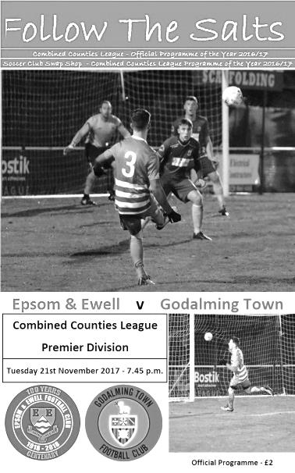
Season hits rock bottom

Tuesday night's match against Godalming Town was hugely important for both clubs. Unfortunately for our club it was the visitors who coped best with the pressure of the situation and they deservedly took the points by three clear goals, leaving us once again adrift at the bottom of the table.

Godalming came into this game on an even worse run than ours, as we had at least won a match recently against Farnham Town. However, the inclusion of a couple of new players in their starting line-up, one of which had been playing for Slough Town's first team just six weeks ago would have helped any confidence issues. For our boys we had some more changes again with Liam Roberts, Joe Loftus-Cheek, Sean White and Ashley Thompson coming in for Taryn Smith, Ben Dyson, Ben Franklin and George Murphy.

In an important match it is key not to give anything away in the opening minutes, but once again we were a goal behind in the opening minutes when a ball out to the right hand side left Bobby Bennett the freedom of the park to stroll in and slide the ball beyond the exposed Conor Young into the far corner of the net. It was only the 6th minute and any concerns the visitors might have felt about this match were swept away in an instant. They went on to control a large part of the opening proceedings with our boys being unable to link up with our front men and in many cases just having to hit a long ball into space knowing it would soon come back again.

Sean White tried a curling effort towards the top corner from twenty yards but Dimi Kyriatis was able to make the save and that was our only shot on target of the half. The remainder of the forty five minutes consisted of general possession and attacks from the visitors. We nearly went 2-0 down as early as the 13th minute to a deep right wing cross that was met at the far post with a good strike but Young had got across and made a great block to keep the ball out. Then three minutes later Bennett got through again on the right but this time fortunately steered his shot beyond the far post.

The only other chance we would fashion in the half came when Adam Heagney delivered a free kick into the danger area and although this was punched away by Kyriatis, the ball was sent back in to the far post where Ashley Thompson cushioned a header back to Loftus-Cheek who then saw his effort on goal deflected wide with from ten yards out but the corner came to nothing.

We had a couple of shots at goal in the opening exchanges of the second half with Heagney and then Roberts both failing to find the target before we had a let off when a close range strike was straight at Young. We introduced Rob Hendry for Roberts but in the 64th minute the game was up as we conceded again. Some nice interplay on the left cut us apart and the ball was squared across the edge of the area to Bobby Webbe who drilled the ball into the net from 18 yards out. Three minutes later the visitors had their third goal as they attacked down the right and squared the ball for Tom Biss the Slough loanee to tap into an empty net. There was a suspicion of offside about this goal and Reisse Griffin picked up a rare yellow card for making his opinions known, but in truth this was probably just frustration with the situation.

Our response to this was a little better and Hendry was cynically taken out by experienced defender Steve Betancourt who was booked for his trouble and became the fifth player to pick up a yellow card for a foul on Hendry in his last three matches. However, Hendry's free kick was an easy one to save. We made two further substitutions with Ben Dyson and Endrit Dobraj coming on for Sean White and Kane Grandison respectively and our best chance came shortly after this when Lloyd Connelly was put through on goal, but hit the ball straight at the keeper from just inside the penalty area.

A Hendry cross was headed wide by Loftus-Cheek before Betancourt took out another player on the edge of the box, this time avoiding a second yellow but the wall was only moved back about five yards and as Dale Marvell tried to wrap his foot around the ball he got it all wrong and the ball sailed high and wide.

On another day we could have taken issue with some erratic decision making by the officials but we were well beaten on the night and cannot use any of that else for an excuse. Our boys were trying hard but found it very difficult to create much of a threat throughout the game and the bad start really didn't help. In fact it was such a disappointing evening that the high point was watching the performance from our former long serving Captain Alex Rodrigues. Just one week short of his 34th birthday he looked completely untroubled throughout the match, as was often the case when he played for us. It was just unfortunate that he was playing for our opponents!

Surely with players of that quality added to their new signings last night Godalming have every chance of closing the gap on the teams above them as they were far better than the AFC Hayes team that we met on Saturday. As for us though, it is hard to see any light at the end of the tunnel right now. There may have been a chink of light after last Tuesday's win over Farnham Town but that door was firmly closed in our faces by the last two results and the trip to Balham on Saturday looks extremely daunting right now if we continue to play like this.

Epsom and Ewell: Conor Young, Sean White, Liam Roberts, Dale Marvell, Alex McKay (c), Reisse Griffin, Adam Heagney, Kane Grandison, Joe Loftus-Cheek, Lloyd Connelly, Ashley Thompson

Subs: Rob Hendry for Roberts (59), Ben Dyson for White (74), Endrit Dobraj for Grandison (81)

Sponsors Player of the Match: Dale Marvell

From behind the goal
Balham 4-0 Epsom & Ewell
Combined Counties League - Premier Division - Saturday 25th November 2017

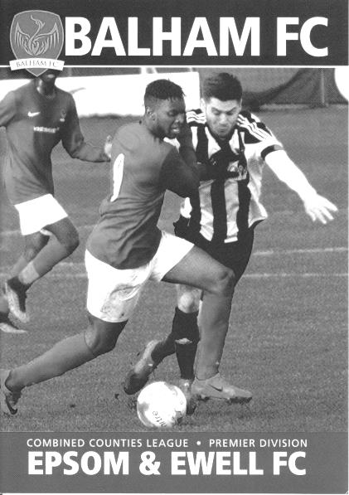
Another bleak day at Wibbandune

In recent seasons our trips to the Wibbandune Playing Fields, the home of Colliers Wood, haven't ended well. This week we made our second visit of the season and suffered another heavy defeat, this time at the hands of their tenants and Premier Division new boys Balham who won by four clear goals.

This was however, a strange match, as we were quite competitive for much of it, only to be sliced open quite badly on occasions, and this led to a scoreline that some might think was harsh on our boys, while others might consider it completely fair.

Maybe things would have been different if Sean White's header not come back off the inside of the post in the opening eighty seconds, but those are the sort of breaks that you get when at the wrong end of the table and to then find ourselves trailing at the half to a superb thirty yard strike into the top corner after being at least as good as our opponents in the first forty-five minutes was hard to take.

In terms of personnel Taryn Smith returned up front, while in midfield Dan Rose returned after suspension and Ben Dyson moved back into the starting eleven. Finally, at the back Scott Murphy returned after injury and Endrit Dobraj came in on the left of what looked to me like a four man defence, although Adam Heagney in particular was given plenty of freedom to roam up the right wing when required.

And it was Heagney who caused the first danger with the clock just ticking into the second minute of the match when the ball came back to him and he delivered a left footed cross. White rose to get the faintest of headers to the ball and was really unlucky to see the ball hit the far post and with Rose coming in for a tap in, Haydn Read, the Balham keeper just got a glove to the ball as it rebounded to divert it away.

We continued to press and Smith wasn't far away with a left footed attempt from outside the penalty area before a great crossfield ball found Liam Roberts, but his attempt to lob the advancing Read wasn't high enough and the effort was blocked away. The home team responded with a powerful long shot but Conor Young had everything behind it and made the save comfortably.

It was clear that the home team had a lot of pace and whilst our back four were playing quite high, this compressed the play a little but left large gaps in behind us and with the pacey Reisse Griffin unavailable we were always likely to get caught from time to time, although Dobraj did well competing against Ibrahim Olutade as he broke through, distracting the striker enough so his shot at Young was weaker. However, the home team were now very much in this match and they fired

over after we lost the ball on the edge of the area before Anis Nuur broke our offside trap and ran through from the right, but his chip was anticipated by Young who was able to reach the ball before it went over him.

The 26th minute contained two attacks. Firstly as we pressed, Read headed the ball away from the edge of his area but it went to Roberts who was unable to find the target from twenty yards, his shot going wide of the post. Within seconds though the home team were attacking us and Young was out quickly to clear, but he only half connected with the ball and had to chase it, eventually losing it way out on the touchline. Fortunately in this time Murphy had dropped back and was able to head the long range attempt at goal back towards the by now retreating keeper! Minutes later a shot on goal from a good left wing run and pull back was deflected out for a corner. At this point our luck ran out as from out of nowhere in the 35th minute Jake Henry decided to have a go from fully thirty yards and the ball sailed right into the top corner, giving Young no chance. It was one of those strikes that you could see was going in the moment he hit it!

We had another scare towards the end of the half but Alex McKay made a good block as the broke on the right hand side, although we almost equalised when Dobraj delivered a deep free kick to Murphy at the far post and he pulled the ball back for Ashley Thompson but from twelve yards out his shot was wide of Read's far post.

Despite matching our hosts for the entire first half it all went wrong just two minutes into the second half when we lost the ball in midfield straight to Olutade who simply ran through and planted the ball past Young who appeared to get a hand to it but couldn't keep it out. Roberts saw his shot deflected wide for a corner but we weren't threatening as much and we made a double substitution, adding a strike pair to the proceedings with Joe Loftus-Cheek and Lloyd Connelly coming on and with Smith moving out to the right flank. Unfortunately it didn't really work out and we created less as the match went on. Young saved low down after they had broken through on the right wing and then a few minutes later they broke down the left, drawing Young out before laying the ball back but we were able to intercept the pass and get the danger cleared.

Shaun Masterson came on for his debut in relief of Roberts who had appeared to possess our only real threat on goal and we were further behind in the 82nd minute when a similar break on the left wing ended with Young making a good save of a low shot but the loose ball fell to Arsen Ujkaj who smashed the ball into the roof of the net from close range. Worse was to come on the 87th minute when they outran us on the right wing and the low ball in presented Olutade with a tap in for his second goal of the afternoon from close range.

Pace is a major threat at this level. We found that out at AFC Hayes last Saturday but at least they only had one nippy striker. Balham had an attacking threat across the front line and whilst I struggled to see how they could have run Westfield that close last week on this performance, it's clear that they have now found their feet at this level and will have no worries about staying up. For us though, another week passes and whilst results went well for us elsewhere, we still have to start winning ourselves, yet it is now three matches in a row without a goal and this has to change soon.

Epsom and Ewell: Conor Young, Adam Heagney, Endrit Dobraj, Scott Murphy, Alex McKay (c), Ashley Thompson, Liam Roberts, Ben Dyson, Taryn Smith, Daniel Rose, Sean White

Subs: Joe Loftus-Cheek for Rose (56), Lloyd Connelly for White (56), Shaun Masterson for Roberts (78)

Club Records - 2nd December
Date | Day | Competition |  | Opponents |  | Scorers
02/12/33 | Sat | London League | A | Finchley | 0-1
02/12/50 | Sat | Surrey Senior Cup 4q replay | A | Hawkers Athletic | 4-3 | S.Faggetter (2), B.Musto, T.Wright
02/12/61 | Sat | Surrey Senior Cup 3q | H | Camberley Town | 6-3 | J.Punter (3), T.Millard, D.Mead, B.Kenyon
02/12/67 | Sat | Athenian League 2 | A | Aveley | 3-2 | J.Eales (2), o.g.
02/12/72 | Sat | Athenian League 2 | A | Hemel Hempstead F.C. | 1-1 | B.Jones
02/12/78 | Sat | Surrey Senior Cup 4q | H | Bae Weybridge | 3-1 | S.Delaney, D.Walker, T.McCready
02/12/80 | Tue | Isthmian League 1 | A | Camberley Town | 2-0 | T.Tuite (2)
02/12/95 | Sat | Isthmian League 3 | A | Hornchurch | 1-0 | S.Smith
02/12/97 | Tue | Isthmian League 3 | A | Kingsbury Town | 1-0 | A.Rawlinson
02/12/06 | Sat | Combined Counties  Premier Division | H | Chertsey Town | 2-1 | A.Pero, o.g.
02/12/14 | Tue | Surrey Senior Cup 2 | H | Camberley Town | 1-0 | A.McGregor
Historical Decades
Date | Day | Competition |  | Opponents |  | Scorers
90 years ago – Epsom Town F.C.
26/11/27 | Sat | Surrey Senior Cup 3q | H | Aquarius | 7-3 | R.Marlow (3), J.Parr (2), F.Watts, F.Behn
80 years ago – Epsom F.C.
04/12/37 | Sat | London League | H | R.N.Depot | 10-1 | J.Jones (4), B.Beglan (2), C.Thompson (2), A.Dempsey, H.Pullen
70 years ago – Epsom F.C.
29/11/47 | Sat | London League | A | Woolwich Poly | 2-4 | E.Watkins, T.Rochester
60 years ago – Epsom F.C.
07/12/57 | Sat | Corinthian League | H | Wembley | 4-1 | J.Sorensen (3), B.French
50 years ago – Epsom & Ewell F.C.
02/12/67 | Sat | Athenian League 2 | A | Aveley | 3-2 | J.Eales (2), o.g.
40 years ago – Epsom & Ewell F.C.
03/12/77 | Sat | Surrey Senior Cup 4q | A | Horley Town | 4-1 | T.Coombe (pen), G.Butler, T.Tuite, R.Parkin
30 years ago – Epsom & Ewell F.C.
01/12/87 | Tue | London Senior Cup 3q | A | Thames Polytechnic | 3-0 | B.Perkins (3)
20 years ago – Epsom & Ewell F.C.
02/12/97 | Tue | Isthmian League 3 | A | Kingsbury Town | 1-0 | A.Rawlinson
10 years ago – Epsom & Ewell F.C.
01/12/07 | Sat | Combined Counties  Premier Division | A | Cobham | 2-3 | D.Smith, R.Burns

History Corner – 2nd December
90 years ago this week it was an emotional time as we defeated Aquarius, the Water Board works team by seven goals to three in the Surrey Senior Cup. Reg Marlow scored his regular hat trick as we won easily but this was to be the final first team match for one of our founders Reg Sperring, who was taking up the opportunity to become a golf professional in Europe. He would return a few years later but would never again represent the first team, although his twin brother Ernie would continue playing for us for almost another decade. There were many presentations at a social event held at the Green Man in Ewell Village after the match, which in our pre-clubhouse days was where almost all the post-match activity took place.

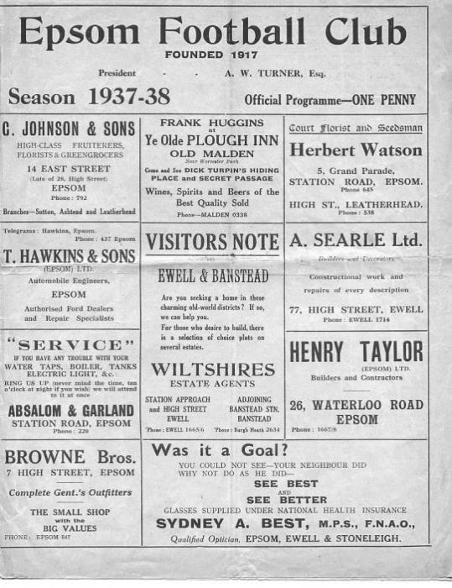
80 years ago this week we hosted the Royal Naval Depot in a London League match at West Street and were battered 10-1. Despite the score line, they were not a poor team as a rule, we just had a very good day at the office! Jimmy Jones scored four goals in this match against the Chatham based club, while Brian Beglan and Charlie Thompson scored a pair each. (see programme pictured)

That evening, the players travelled across the English Channel for a friendly against Dunkirk F.C. just 24 hours later. I’ve no idea how this match came about, although the London League and the Paris League did play representative matches and it’s possible that there was a connection there as Jones and another regular Epsom servant Bobby Gill regularly played in those matches. Either way, we were out of our depth and lost 7-0!

60 years ago this week we defeated Wembley 4-1 in a Corinthian League match with Jorgen Sorensen scoring a hat trick. Jorgen, or Jan as he was better known, was a Danish International and had also played for Erith & Belvedere and Sutton United, but had two gents outfitters, one in Stoneleigh and one in Ewell, and he would play for us for a few years. Additionally, two of his sons, Erik and Mick would also go on to play for us in future years.

56 years ago today Jim Punter scored a hat trick as we beat Camberley Town 6-3 in a Surrey Senior Cup tie with the other goals coming from Brian Kenyon, Dick Mead and Tommy Millard. Tommy is 85 now and is still active on Facebook!

30 years ago this week Brian Perkins scored a second half hat trick as we finally got past Thames Polytechnic in the London Senior Cup. In a match switched to West Street the Amateurs held out for forty-five minutes but in the end we progressed 3-0. Also 30 years ago this month we announced that we had sold West Street and would be leaving in five years, although the advised departure date of 1992 would be extended by a year before we would finally leave.

11 years ago today we beat local rivals Chertsey Town thanks to a comedy own goal. With the scores locked at 1-1, we hit the bar. As it rebounded, their defender tried to control the ball with his chest before volleying it clear, but the contact was too firm and the ball was over the line by the time he made a second contact which only succeeded in firing the ball into the roof of the net!

From behind the goal
Sutton Common Rovers 0-0 Epsom & Ewell
Epsom & Ewell won 5-4 on penalties
Surrey Senior Cup – Second Round - Monday 27th November 2017

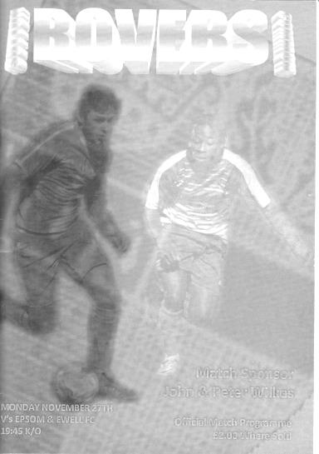
Clinical penalties send Salts through in the County Cup

Ultimately, when looking back at this match the bare facts will read that Anson Cousins missed a crucial spot kick and we progressed at the expense of local rivals Sutton Common Rovers. This might appear harsh, but that is the nature of penalty shootouts, and regrettably there will be little else that this match will be remembered for.

The Surrey Senior Cup is a once great competition that we have entered every year it has been contested since 1924. There was a time when thousands used to gather to watch these local contests, and whilst those sort of numbers may belong to another era, there is no denying that the cup represents a very low priority amongst senior clubs nowadays. Since the Surrey FA's ill-advised decision to remove the exemption system and then to allow ties to be played midweek, it has become a "filler" for many clubs and in recent seasons we have played Sutton United twice and Leatherhead, all of whom have fielded their reserve teams, all because they do not want to commit their main players to the potential of an six extra matches on top of their busy schedules.

This time out it was Sutton Common Rovers who decided to give many of their players a rest and it is hard to disagree with their priorities. Riding high in the League and with a League Cup tie coming up, which they are now arguably favourites to win, it made sense to give some of their squad a run out and this made for a far more even contest than our previous meeting back in August. Unfortunately it was so even for large patches that very little real goalmouth action took place!

The home team provided us with a scare as early as the eleventh minute when a long range effort, that might even have been a cross, bounced off the top of our crossbar and out for a goal kick. In response a good right wing delivery was met by an air shot from Ben Dyson in a fairly good position. It was only a half chance, but you wondered how many of these would come along, bearing in mind a run of 309 minutes without a goal that would extend by another ninety minutes by the end of this match.

Half an hour into the contest the home side threatened again but were unable to get a far post header on target from fairly close range and a few minutes later Dyson had another opportunity as he raced through on goal, but his touch was heavy and Ollie Ellaway was able to make the block with the danger cleared soon afterwards. A similar opportunity occurred in the 37th minute but again Ellaway was able to make a really good save whilst on the

ground as Dyson attempted to go around him.

As we approached the half time interval Taryn Smith also got through, but Ellaway stole the ball from him just as it looked like our man had got past him. Right at the end of the half, the home side had a lucky escape when a right wing cross was headed by a defender against former Salt Craig Hastings but the ball fell kindly for Ellaway and the teams went off at the break scoreless.

In all honesty, scoring chances became fewer still after the break. The home side had been quite direct in the opening forty-five minutes and clearly they were told in no uncertain terms to get the ball down and pass it around a bit on Sutton's plastic surface. This worked well for a while and they held a fair bit of possession but created little of real danger as Alex McKay and Reisse Griffin held firm at the back, well protected by their team mates. In fact, by some distance this was Conor Young's quietest outing since re-joining us!

We made our only substitution of the evening after 74 minutes when Lloyd Connelly came on for Liam Roberts, although the whole procedure had an element of farce about it as the referee deemed that he wasn't ready to take the field originally, but Roberts had by now taken his shirt off! Luckily nothing serious occurred to the ten men and Connelly took the field about ninety seconds after he was meant to.

There was a big shout from SCR for handball in the 80th minute and it must be admitted that when the ball hit our player, it did sound like a handball if you know what I mean! However, it wasn't given and we had a couple more half chances as the five minutes of injury time was played with Smith setting up Sean White who delivered a teasing cross that nearly got past everyone although Ellaway clutched the ball at the last minute. Moments later Adam Heagney delivered a cross just beyond Smith but White was there to strike at goal, only to see the ball rebound kindly for Ellaway to gather again. It was no surprise to anyone in the ground that this match ended up going to penalties!

So we lined up for what was the seventh penalty shootout in our history and our second in this competition, following a bizarre 15-14 shootout loss to Egham Town in 2003, and I'm pleased to report that for the third time in those seven lotteries that we came out on top. In fact much credit should be given to the five takers who gave Ellaway no chance whatsoever with any of them and when Cousins saw his fourth penalty superbly turned away by Young, Lloyd Connelly added his name to a very small list of players who have scored a winning penalty in a shootout, following Terry Fennessey in 2010 and James Taylor in 2015.

Rob Hendry scored our first penalty with a clinical strike that matched his previous spot kicks for the club, before Scott Murphy blasted his past Ellaway. Adam Heagney's was more cultured but no less effective and Taryn Smith put his well out of reach too. Connelly's penalty went in just grazing the crossbar on the way, but they all count and so we go into the hat for what will be our 208th match in this competition.

Although it is hard to know what positives to take from a match like this when the opposition make many changes to their line-up, it must be said that we looked a lot more secure at the back and we probably just shaded the good chances in the match. It is nice to see our boys win a match from time to time and we had a clean sheet into the bargain!

Epsom and Ewell: Conor Young, Adam Heagney, Sean White, Reisse Griffin, Alex McKay (c), Ashley Thompson, Liam Roberts, Scott Murphy, Rob Hendry, Taryn Smith, Ben Dyson

Subs: Lloyd Connelly for Roberts (74)

Centre page for results

Centre page for results




Guildford City – History
1921 - 1974
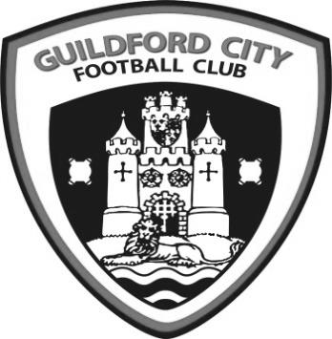
The first club in the town were formed in 1877 as Guildford FC., known as the “Pinks”. By the end of 1920 a professional side was formed, and in May 1921 they were accepted into the Southern League, the equivalent of today’s Conference League.

1927 saw Guildford become a Diocese and, coupled with the planned cathedral, it was believed that Guildford would become a city so the Club was renamed Guildford City. In 1928-29 City were drawn at home to Queen’s Park Rangers in the FA Cup First Round proper and won 4-2 in front of almost 8,000 spectators. The immediate pre-war years saw another famous FA Cup victory, this time over Reading, whilst 1937/38 saw Guildford City lift the Southern League Championship trophy for the first time. The following year a record crowd of 9,932 spectators crammed in to Joseph’s Road to watch an epic FA Cup First Round replay versus local rivals Aldershot.

In 1951, City sold future England cap Jimmy Langley to Leeds. Another League Championship was achieved in 1955-56, and then in 1967-68 Guildford embarked upon a memorable FA Cup run. Leading 2-1 at Brentford in the First Round proper, the match was abandoned due to snow. A 2-2 draw in the rearranged fixture saw 7,289 fans cram into Joseph’s Road to roar City on to a famous 2-1 victory in the replay. A further 8,774 saw City fall narrowly to Newport County in the Second Round, but the heroes of that era, players like Tony Burge and long-serving Darby Watts, will be remembered for ever as legends. In 1974 on-going financial problems came to a head and, despite the best efforts of Bill Bellerby and John Daborn, it was announced that the Club was to merge with Dorking. Subsequently the final game was played on 12 February 1974, when City beat Folkestone 2-0 in front of 625 fans.

1996 – Present
After many years of discussions, the club re-emerged as AFC Guildford in 1996 when the then Mayor of Guildford John Woodhatch consulted the Burpham FC committee as to whether the club would be prepared to change its name and move to the Spectrum Leisure Centre.

After a brief spell in the Surrey Premier League, Guildford joined the newly formed Combined Counties League, winning Division One in 2003-04. After a 12 month period as Guildford United, the club was re-named the historically significant ‘Guildford City’, after an absence of thirty years. 2007-2008 saw City claim a runner up finish in the Combined Counties Premier League, under the management of Scott Steele and Lloyd Wye. Then saw a period of struggle which was only alleviated by the inspirational appointment of Kevin Rayner, and his assistant Roly Martin, who took charge in spring 2009.

Their first full season at City saw a much improved seventh place finish in 2009-10. The following year saw a good run in the FA Vase, an incredible FA Cup victory at Ryman Premier Tonbridge Angels, but also the Combined Counties Premier Division Championship. A second Combined Counties Championship was gained in 2012, resulting in an emotional return to the Southern League after a gap of 38 years.

Change was on the way after a creditable ninth place finish in the Central division. At the conclusion of 2012-13 Rayner departed for a new chapter in his career. However in November 2013 he returned to the Spectrum to lead an ultimately unsuccessful battle against relegation from the Southern League. After a poor start to the 2014-15 Combined Counties League season, Kevin Rayner departed in November to be replaced by local coach Donovan Chislett who ultimately saved the club from relegation in an exciting climax to the season.

Chislett himself departed in September 2015 to be replaced by former Godalming & Farncombe Athletic FC manager Dean Thomas. After exactly 12 months Dean departed to be replaced by his assistant Steve Dormer. Dormer in turn saw the 2016-17 season out before moving on to Fleet Town. Former Merrow FC manager Chris Balchin will now take the club forward with a period of managerial and player stability being key.

EL Records Premier Challenge Cup
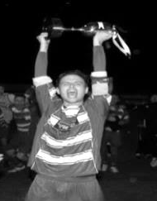
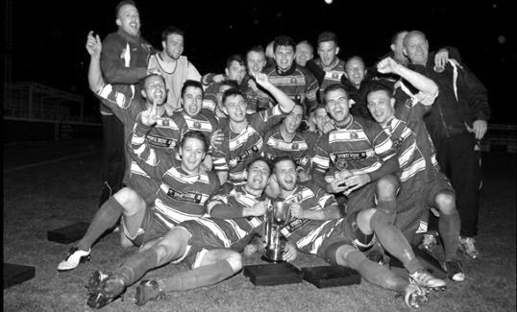
Third Round
Cobham | 5/12 | Farnham Town
North Greenford United | 0-4 | Colliers Wood United
Sutton Common Rovers | 4/12 | Redhill
Godalming Town | 5/12 | Chessington & Hook United
Knaphill | 5/12 | Kensington Borough
Bedfont Sports | 0-1 | Walton & Hersham
Spelthorne Sports | 1-0 | Chertsey Town
Worcester Park | 9/12 | FC Deportivo Galicia

Surrey Senior Cup
Preliminary Round
Westfield | 3-2 | Abbey Rangers
Dorking Wanderers | 4-1 | Walton Casuals
Knaphill | 1-2 | Met Police
First Round
Westfield | 2-2 - 4-2p | Camberley Town
Woking | 5/12 | Chipstead
Chertsey Town | 1-2 | Spelthorne Sports
Dorking Wanderers | 4-1 | Godalming Town
Horley Town | 5/12 | Kingstonian
AFC Croydon Athletic | 1-5 | Met Police
Tooting & Mitcham United | 1-0 | Corinthian Casuals
Carshalton Athletic | 6-2 | Egham Town
Croydon | 2-2 - 11-12p | Molesey
Farnham Town | 2-2 - 5-4p | Whyteleafe
Sutton United | 2-1 | Redhill
Banstead Athletic | 2-5 | Leatherhead
Sutton Common Rovers | 0-0 – 4-5p | Epsom & Ewell
Guildford City | 2-2 - 3-5p | Colliers Wood United
Merstham | 3-0 | Walton & Hersham
South Park | 2-2 - 4-2p | Ashford Town (Mx)

Every Opponent A-Z
Over the years we have played many, many different opponents. Exactly how many is a difficult question, as it all depends on your definition. Are Camberley & Yorktown different to Camberley Town, or are Epsom Town different to Epsom F.C. or Epsom & Ewell F.C.?

In my analysis I have classed them as the same team, and will work through them all from A to Z. Some we have played many times, whilst others we have met maybe just once or twice. Enjoy!


Wick: Played 2 - W1 D1 L0 - F5 A3 - PPG - 2.00 - Very Good

Back in 1988/89 we were playing in the F.A.Vase for the first time since our Fourth Round appearance in 1977/78. We had defeated Chatham Town 5-0 at Maidstone Road before extra-time wins at Banstead Athletic (2-1) and at home to Three Bridges (6-2!) gave us a tie in the last 64 away at Wick. They were, and are, a fairly small club on the outskirts of Littlehampton and although Richard Strong put us ahead at Crabtree Lane with a thumping header from a corner, we were pulled back to 1-1 and extra time in the gloom couldn’t separate the two teams.

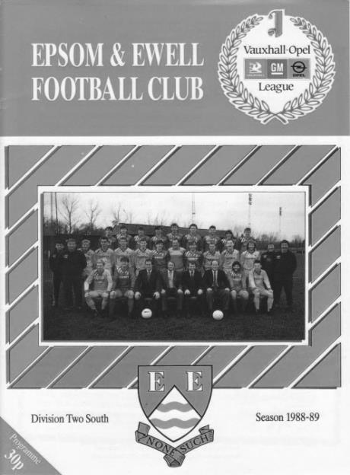
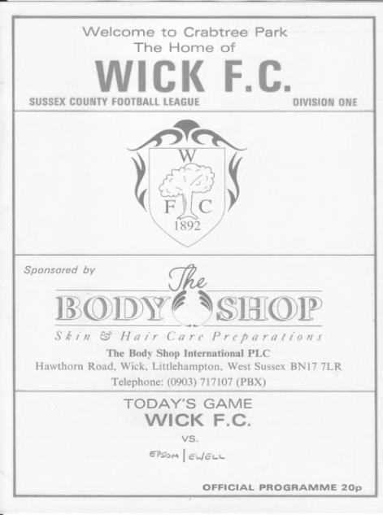
The replay three days later was a nervy affair as we conceded after 15 minutes and then pushed for the remainder of the match for an equaliser. I can still remember the 89th minute equaliser and Neil Robson grinning as the left wing cross came over for him to apply a close range finish at the West Street end of the ground to force extra time once again. This time Wick were a beaten side and we scored three times to win 4-2 in the end and reach the Fourth Round once again. The run ended at home to Hailsham, appropriately in extra time and in 26 Vase campaigns since, we have only got as far as the Fourth Round once more, at Long Buckby in 2010.

Wick have never really hit the heights in the Sussex League or its new name the Southern Combination, and have spent much of it at Step Six, having also gone under the name of Wick and

Barnham United for a while. Now back as Wick F.C. they are in the promotion places at Step Six right now so it may not be long before they are again back up with the bigger Sussex clubs.

Willesden: Played 5 - W3 D1 L1 - F11 A6 - PPG - 2.00 - Very Good

Our very first meeting with Willesden came at the end of the 1949/50 season and was a friendly match as both teams’ league seasons had come to an end. We didn’t really get into the contest though and lost 3-0 in a match which was hardly covered in the local papers. They were in the Spartan League at the time.

Our next pair of meetings came in 1975/76 following our promotion back into the Athenian League Division Two which they had joined from the London League in 1974. We made our second visit to the King Edward VII Sports Ground in Donnington Road on 4th October 1975, just over a quarter of a century after the last meeting, but the game finished goalless. We were a good side though and would finish runners-up, so it was no surprise when we defeated them 4-0 on 31st January 1976.

We spent a season in the Athenian League Division One before accepting a place in the Isthmian League Division Two, but Willesden, and also Farnborough Town were promoted up from Division Two, presumably because their grounds were of a decent standard, so we met again as league equals in 1977/78.

However, we would become Champions that season and won there 3-1 and at home by four goals to two on the 11th March 1978 which was also the last time we would meet. We went up while they remained in Division Two until 1981, at which point the club folded.

It is interesting to note that in our three wins we had three separate players scoring a hat trick! Tommy Tuite scored in the 1976 win, while Frank Allen and then Richard Parkin did the honours in the latter matches.

The story doesn’t quite end there. The ground itself still exists and is now better known as the National Hockey Centre. Also a new club Willesden Hawkeye came around a few years later and whilst it didn’t stick around for long, it did provide the football world with a future Premier League player, Barry Hayles.

Wills Sports: Played 3 - W3 D0 L0 - F13 A6 - PPG - 3.00 - Perfect

Wills Sports were a short lived team that were Carshalton based and came up through the junior ranks to compete for a few seasons in the Surrey Senior League from 1931 to 1936. We met on three occasions during their brief existence and won all three but that doesn’t tell the full story.

Our first meeting came on 23rd January 1932 in the First Round of the Surrey Senior Cup. We were a very good team that year and seven days previously had visited Wycombe Wanderers in the last 32 of the Amateur Cup in front of 7,000 spectators. We lost that match though, and we were only level at 2-2 in this match at half time before we ran away with it in the final thirty-five minutes to win 6-2. Reg Marlow scored a hat trick while Bob Earl got two and Terry Birch scored the other goal. Wills were top of their League at that point.

The following season we met in the Amateur Cup, also at West Street and although Tommy Dunne put us ahead, the score after 90 minutes was 1-1 and we required two goals in the first period of extra time to progress. The local papers were harsh, saying "Epsom supporters were almost moved to tears by the ineptness of their own forwards". And some people think my reports are harsh!

Our final meeting came two seasons later on 3rd November 1934 and took place at their Hill Farm ground in Carshalton; a better location of which I have so far been unable to identify! We led 2-1 at the half but two goals in five minutes near the end gave Wills Sports the lead before Jimmy Jones equalised in the 90th minute. Then with a replay looming Tommy Dunne popped up to score the winner in the 119th minute! We reached the last 64 that season, losing to Wimbledon.

Combined Counties League Premier Division
Opponents All-time Records
inc Monday  27th November | P | W | D | L | F | A | PPG | GD | Best  Win | Worst  Loss
Abbey Rangers | 4 | 3 | 0 | 1 | 11 | 4 | 2.25 | +7 | 7-1 | 2-3
Horley Town | 31 | 21 | 5 | 5 | 69 | 34 | 2.19 | +35 | 6-0 | 1-3
Sutton Common Rovers | 14 | 9 | 3 | 2 | 30 | 19 | 2.14 | +11 | 4-0 | 0-5
Spelthorne Sports* | 8 | 5 | 2 | 1 | 16 | 11 | 2.13 | +5 | 6-2 | 1-5
Banstead Athletic | 38 | 23 | 7 | 8 | 62 | 38 | 2.00 | +24 | 5-0 | 0-4
Bedfont Sports | 12 | 7 | 2 | 3 | 21 | 19 | 1.92 | +2 | 5-1 | 0-7
Guildford City | 18 | 11 | 1 | 6 | 35 | 22 | 1.89 | +13 | 5-1 | 1-5
Westfield | 21 | 12 | 3 | 6 | 43 | 36 | 1.86 | +7 | 6-1 | 0-4
Colliers Wood United | 24 | 14 | 2 | 8 | 47 | 39 | 1.83 | +8 | 4-0 | 0-5
Farnham Town | 17 | 9 | 4 | 4 | 30 | 25 | 1.82 | +5 | 3-0 | 1-4
Knaphill | 9 | 5 | 1 | 3 | 19 | 15 | 1.78 | +4 | 4-0 | 2-6
Walton & Hersham | 52 | 25 | 11 | 16 | 105 | 99 | 1.65 | +6 | 8-0 | 1-9
Hanworth Villa | 18 | 8 | 5 | 5 | 39 | 28 | 1.61 | +11 | 5-0 | 1-4
Camberley Town** | 91 | 38 | 23 | 29 | 159 | 126 | 1.52 | +33 | 9-1 | 0-4
Godalming Town | 2 | 1 | 0 | 1 | 2 | 4 | 1.50 | -2 | 2-1 | 0-3
Redhill | 34 | 14 | 2 | 18 | 63 | 74 | 1.29 | -11 | 7-2 | 2-8
Chertsey Town | 51 | 19 | 5 | 27 | 77 | 95 | 1.22 | -18 | 3-0 | 0-7
North Greenford United | 13 | 4 | 2 | 7 | 19 | 24 | 1.08 | -5 | 3-0 | 1-4
AFC Hayes | 11 | 2 | 3 | 6 | 18 | 20 | 0.82 | -2 | 7-0 | 0-3
CB Hounslow United | 4 | 1 | 0 | 3 | 6 | 11 | 0.75 | -5 | 2-0 | 1-5
Balham | 1 | 0 | 0 | 1 | 0 | 4 | 0.00 | -4 | x | 0-4
* includes one loss on penalties v Spelthorne and one win on penalties v Sutton Common Rovers
** includes one abandoned match v Camberley

Match and Ball Sponsorships – 2017/18
Opponent | Date | Match Sponsor | Ball Sponsor
Banstead Athletic (FAC) | 06/08/17 | Club President - Stella Lamont
Chertsey Town | 15/08/17 | EEFC Management Committee
Redhill | 02/09/17 | Building Shop Ltd
Spelthorne Sports | 09/09/17 | In memory of Betty Dyke
Horley Town | 12/09/17 | Alex McKay (Senior)
Hanworth Villa | 23/09/17 | Jack Jarman
North Greenford United | 28/10/17 | Marvin and Kathy Hough
Farnham Town | 14/11/17 | In memory of Dave and Lizzie Marshall
Godalming Town | 21/11/17 | Building Shop Ltd
Guildford City | 02/12/17 | John Bonner
Abbey Rangers | 16/12/17
Walton & Hersham | 30/12/17 | Jeff and Arnold Pye
Balham | 20/01/18
Sutton Common Rovers | 03/02/18
CB Hounslow United | 13/02/18
Knaphill | 24/02/18
Camberley Town | 10/03/18
Bedfont Sports | 24/03/18
Colliers Wood United | 30/03/18
Banstead Athletic | 02/04/18 | Nathan Lambert – 10 years old today!
Westfield | 14/04/18
AFC Hayes | 28/04/18 | Club President - Stella Lamont
Match sponsorship costs just £60.00.

Sponsorship includes:

Admission, programmes and hospitality for three people.

A full page advert in the programme and mascot for the day (if required).

Also, you get to choose the player of the match, who will receive a prize

If you are interested, just speak to a Committee Member,
or drop me an email at: richard.c.lambert@gmail.com

Player Sponsorship
Here is the latest list for 2017/18, with new photos showing all of our players and Management that are available for sponsorship. Other new players will be added shortly.

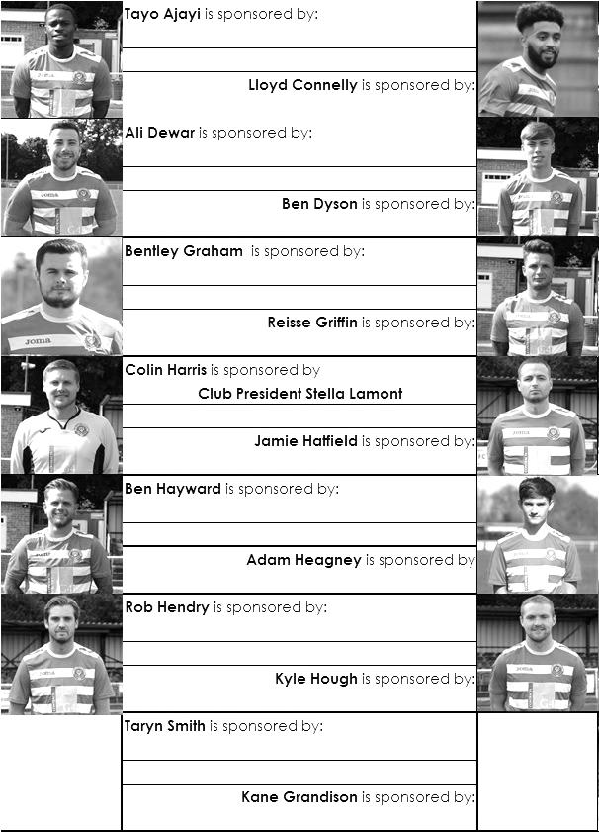

Sponsorship costs just £40 and it is easy to do. Just select a player who has not been previously sponsored and let a Committee Member know that you would like to sponsor them. Beware though. Until we have received the money it is possible for someone to jump in front of you, so don’t delay, sponsor today!

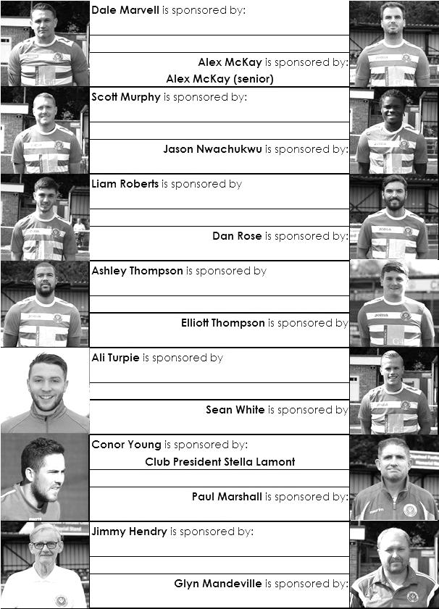

Salts Super Six Predictor
The Salts Super Six Predictor is up and running again with a jackpot of £206 and the tickets are on sale at today’s game to the left of the gate. The matches are to be played this Saturday and are all Premier League this week.

The competition is easy to play! To win, you simply need to predict the results of six matches correctly from the three options, fill in the form and make sure it is back with our seller before the deadline on the ticket. The latest fixtures are shown below.

If you are a club regular, you just need to place your name on the sheet, although if you aren’t, then we’ll need a contact number from you too. We will announce any winners on the website within three working days, so don’t worry, we won’t miss you!

Please note that if there is more than one winner, the prize pot would be shared between the winners. All you need to do now is have a go, as many times as you like!

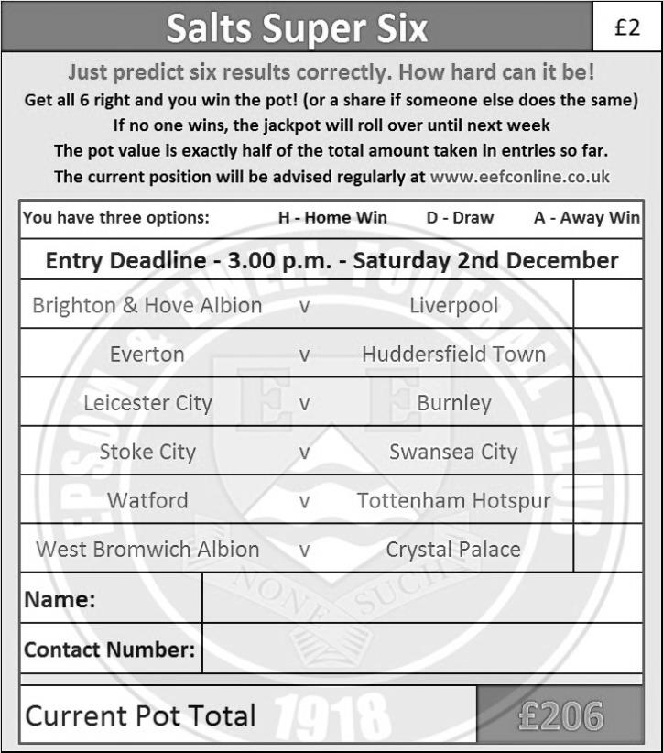

Good luck!

Merchandise
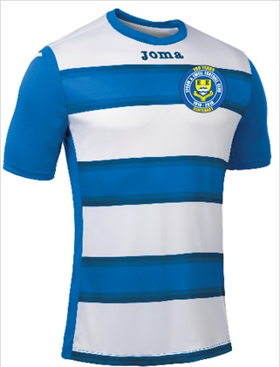
To celebrate our Centenary season we are shortly to have a new kit which will also contain our brand new Centenary badge. We will also be selling polo shirts in either Royal Blue or White.

The costs are being finalised now but if you would like to purchase either a replica new shirt or polo shirts, then let us know and we will get them to you for Christmas or maybe just afterwards. You know where we are!

Be part of the Salts Centenary!

#Saltsfamily

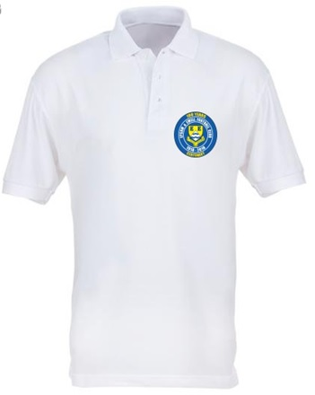
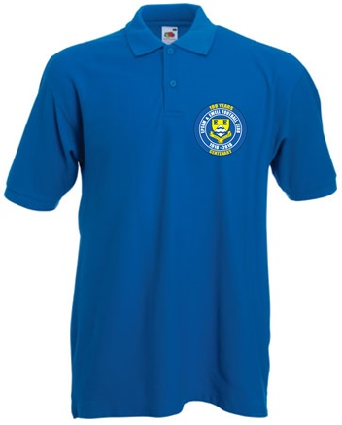

Combined Counties League – Premier Division
Saturday, 2nd December 2017 - Kick-off 3.00 p.m.
Epsom and Ewell  (Royal Blue & White hoops) | V |  | Guildford City  (Red / White)
Squad | NUMBERS |  | Squad
Conor Young |  |  | Kornel Ziobrowski
Reisse Griffin |  |  | Chris Tancock
Sean White |  |  | Shaun Johnson
Scott Murphy |  |  | Tom Booth
Ben Dyson |  |  | Daryl Bryan-Samuels
© Alex McKay |  |  | Nemo Adams ©
Liam Roberts |  |  | David Burton
Rob Hendry |  |  | Luke Beale
Taryn Smith |  |  | Louie Downey
Lloyd Connelly |  |  | David Opuku
Adam Heagney |  |  | Robbie Mundow
Ashley Thompson |  |  | Nathaniel Williams
Daniel Rose |  |  | Miguel Anderson
Endrit Dobraj |  |  | Mark Watkins
Kyle Hough |  |  | Dan Stewart
Jason Nwachukwu |  |  | George Pilbeam
Ben Franklin |  |  | Jordan Gallagher
Shaun Masterson |  |  | Francois Gabbidon
Kane Grandison |  |  | Andre Morais
Calum Kennedy
Jamie Hatfield
Joe Jasper
Ali Dewar
Ben Hayward
Glyn Mandeville | MANAGER |  | Chris Balchin
Alex McKay | ASSISTANT |  | Dave Powell
Neil Grant / Jimmy Hendry | COACH / PHYSIO |  | Tony Millar
REFEREE: T.Yesilyurt
ASSISTANTS: K.Corrick, P.Maskell
Today’s Match and Match Ball are kindly sponsored by:
regular supporter John Bonner

OUR NEXT VISITORS TO HIGH ROAD
Abbey Rangers
Cherry Red Combined Counties League – Premier Division
Saturday 16th December 2017 – 3.00 p.m.

